### **What is SHA-256?**

The SHA-256 algorithm is one flavor of SHA-2 (Secure Hash Algorithm 2), which was created by the National Security Agency in 2001 as a successor to SHA-1. SHA-256 is a patented cryptographic hash function that outputs a value that is 256 bits long.

## **Step-by-step SHA-256 hash of “hello world”**

### **Step 1 – Pre-Processing**

* Convert “hello world” to binary:



* Append a single 1:



* Pad with 0’s until data is a multiple of 512, less 64 bits (448 bits in our case):

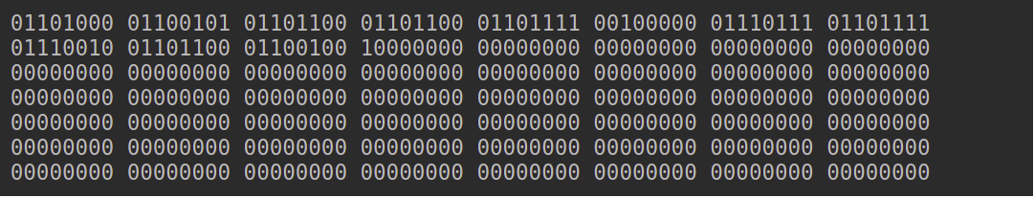

* Append 64 bits to the end, where the 64 bits are a big-endian integer representing the length of the original input in binary. In our case, 88, or in binary, “1011000”.

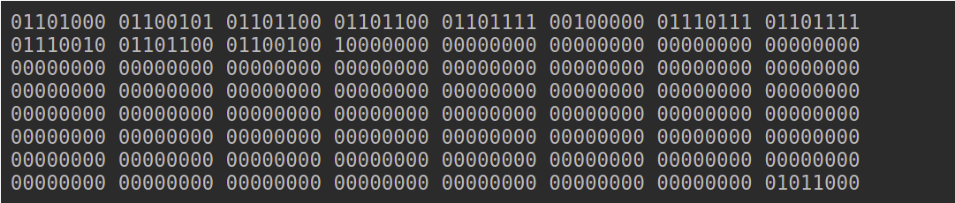

Now we have our input, which will always be evenly divisible by 512.

### **Step 2 – Initialize Hash Values (h)**

Now we create 8 hash values. These are hard-coded constants that represent the first 32 bits of the fractional parts of the square roots of the first 8 primes: 2, 3, 5, 7, 11, 13, 17, 19

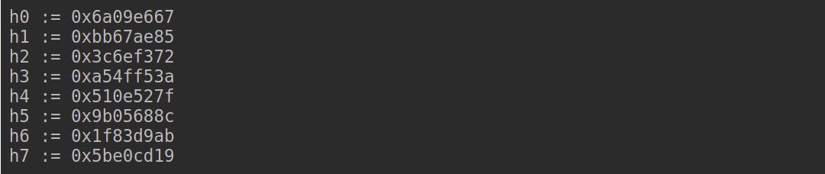

### **Step 3 – Initialize Round Constants (k)**

Similar to step 2, we are creating some constants. This time, there are 64 of them. Each value (0-63) is the first 32 bits of the fractional parts of the cube roots of the first 64 primes (2 – 311).

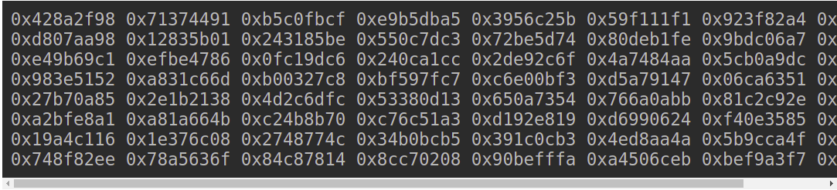

### **Step 4 – Chunk Loop**

The following steps will happen for each 512-bit “chunk” of data from our input. In our case, because *“hello world”* is so short, we only have one chunk. At each iteration of the loop, we will be mutating the hash values h0-h7, which will be the final output.

### **Step 5 – Create Message Schedule (w)**

* Copy the input data from step 1 into a new array where each entry is a 32-bit word:

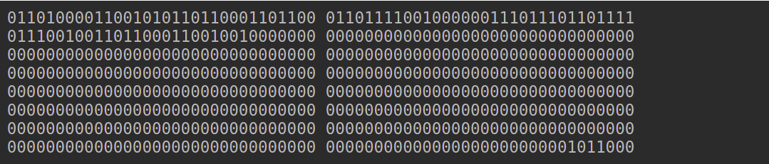

* Add 48 more words initialized to zero, such that we have an array **w[0…63]**

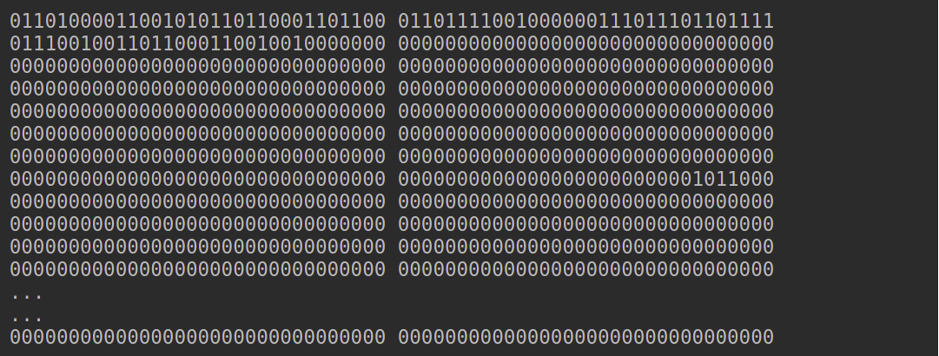

* Modify the zero-ed indexes at the end of the array using the following algorithm:
* For **i** from w[16…63]:
  + s0 = (w[i-15] rightrotate 7) xor (w[i-15] rightrotate 18) xor (w[i-15] rightshift 3)
  + s1 = (w[i- 2] rightrotate 17) xor (w[i- 2] rightrotate 19) xor (w[i- 2] rightshift 10)
  + w[i] = w[i-16] + s0 + w[i-7] + s1

Let’s do w[16] so we can see how it works:

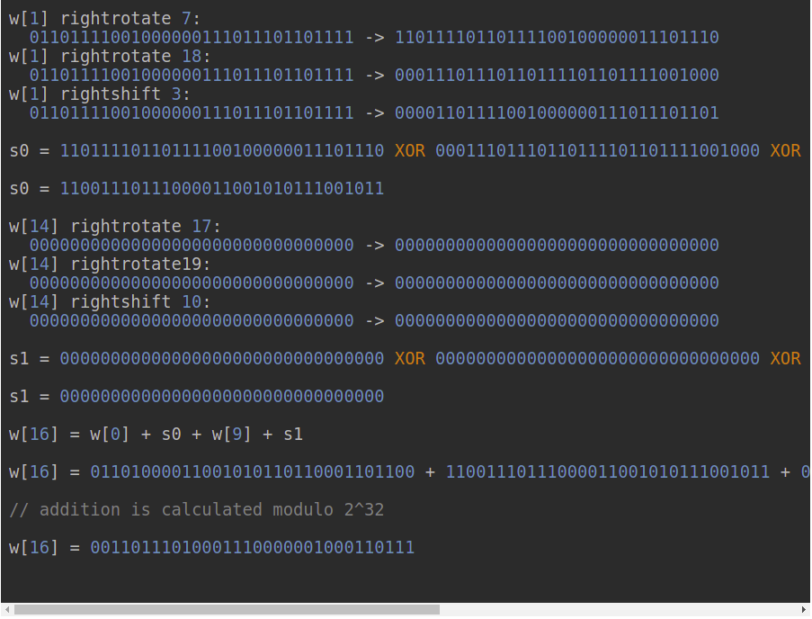

This leaves us with 64 words in our message schedule (w):

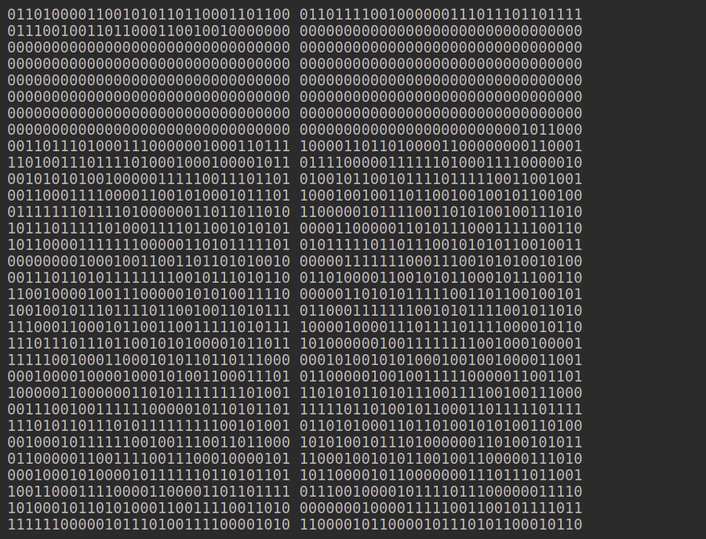

### **Step 6 – Compression**

* Initialize variables **a, b, c, d, e, f, g, h** and set them equal to the current hash values respectively. **h0, h1, h2, h3, h4, h5, h6, h7**
* Run the compression loop. The compression loop will mutate the values of **a…h**. The compression loop is as follows:
* for i from 0 to 63
  + S1 = (e rightrotate 6) xor (e rightrotate 11) xor (e rightrotate 25)
  + ch = (e and f) xor ((not e) and g)
  + temp1 = h + S1 + ch + k[i] + w[i]
  + S0 = (a rightrotate 2) xor (a rightrotate 13) xor (a rightrotate 22)
  + maj = (a and b) xor (a and c) xor (b and c)
  + temp2 := S0 + maj
  + h = g
  + g = f
  + f = e
  + e = d + temp1
  + d = c
  + c = b
  + b = a
  + a = temp1 + temp2

Let’s go through the first iteration, all addition is calculated modulo 2^32:

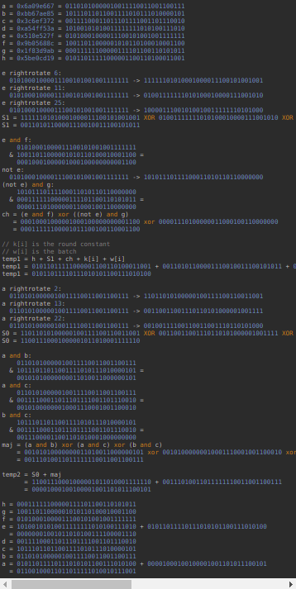

That entire calculation is done 63 more times, modifying the variables a-h throughout. We won’t do it by hand but we would have ender with:

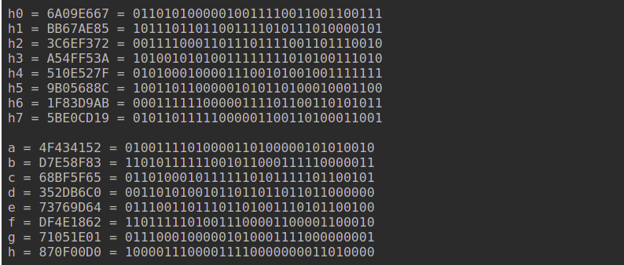

## **Step 7 – Modify Final Values**

After the compression loop, but still, within the *chunk* loop, we modify the hash values by adding their respective variables to them, a-h. As usual, all addition is modulo 2^32.

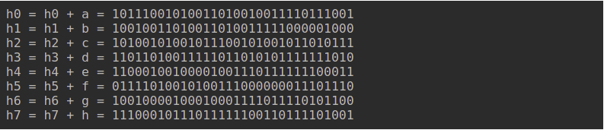

## **Step 8 – Concatenate Final Hash**

Last but not least, slap them all together, a simple string concatenation will do.



Done! We’ve been through every step (sans some iterations) of SHA-256 in excruciating detail

*Pseudocode:*

**Note 1:** All variables are 32 bit unsigned integers and addition is calculated modulo 232

**Note 2:** For each round, there is one round constant k[i] and one entry in the message schedule array w[i], 0 ≤ i ≤ 63

**Note 3:** The compression function uses 8 working variables, a through h

**Note 4:** Big-endian convention is used when expressing the constants in this pseudocode,

and when parsing message block data from bytes to words, for example,

the first word of the input message "abc" after padding is 0x61626380

**Initialize hash values:**

(first 32 bits of the fractional parts of the square roots of the first 8 primes 2..19):

h0 := 0x6a09e667

h1 := 0xbb67ae85

h2 := 0x3c6ef372

h3 := 0xa54ff53a

h4 := 0x510e527f

h5 := 0x9b05688c

h6 := 0x1f83d9ab

h7 := 0x5be0cd19

**Initialize array of round constants:**

(first 32 bits of the fractional parts of the cube roots of the first 64 primes 2..311):

k[0..63] :=

0x428a2f98, 0x71374491, 0xb5c0fbcf, 0xe9b5dba5, 0x3956c25b, 0x59f111f1, 0x923f82a4, 0xab1c5ed5,

0xd807aa98, 0x12835b01, 0x243185be, 0x550c7dc3, 0x72be5d74, 0x80deb1fe, 0x9bdc06a7, 0xc19bf174,

0xe49b69c1, 0xefbe4786, 0x0fc19dc6, 0x240ca1cc, 0x2de92c6f, 0x4a7484aa, 0x5cb0a9dc, 0x76f988da,

0x983e5152, 0xa831c66d, 0xb00327c8, 0xbf597fc7, 0xc6e00bf3, 0xd5a79147, 0x06ca6351, 0x14292967,

0x27b70a85, 0x2e1b2138, 0x4d2c6dfc, 0x53380d13, 0x650a7354, 0x766a0abb, 0x81c2c92e, 0x92722c85,

0xa2bfe8a1, 0xa81a664b, 0xc24b8b70, 0xc76c51a3, 0xd192e819, 0xd6990624, 0xf40e3585, 0x106aa070,

0x19a4c116, 0x1e376c08, 0x2748774c, 0x34b0bcb5, 0x391c0cb3, 0x4ed8aa4a, 0x5b9cca4f, 0x682e6ff3,

0x748f82ee, 0x78a5636f, 0x84c87814, 0x8cc70208, 0x90befffa, 0xa4506ceb, 0xbef9a3f7, 0xc67178f2

**Pre-processing (Padding):**

begin with the original message of length L bits

append a single '1' bit

append K '0' bits, where K is the minimum number >= 0 such that L + 1 + K + 64 is a multiple of 512

append L as a 64-bit big-endian integer, making the total post-processed length a multiple of 512 bits

**Process the message in successive 512-bit chunks:**

break message into 512-bit chunks

for each chunk

create a 64-entry message schedule array w[0..63] of 32-bit words

(The initial values in w[0..63] don't matter, so many implementations zero them here)

copy chunk into first 16 words w[0..15] of the message schedule array

**Extend the first 16 words into the remaining 48 words w[16..63] of the message schedule array:**

for i from 16 to 63

s0 := (w[i-15] rightrotate 7) xor (w[i-15] rightrotate 18) xor (w[i-15] rightshift 3)

s1 := (w[i- 2] rightrotate 17) xor (w[i- 2] rightrotate 19) xor (w[i- 2] rightshift 10)

w[i] := w[i-16] + s0 + w[i-7] + s1

**Initialize working variables to current hash value:**

a := h0

b := h1

c := h2

d := h3

e := h4

f := h5

g := h6

h := h7

**Compression function main loop:**

for i from 0 to 63

S1 := (e rightrotate 6) xor (e rightrotate 11) xor (e rightrotate 25)

ch := (e and f) xor ((not e) and g)

temp1 := h + S1 + ch + k[i] + w[i]

S0 := (a rightrotate 2) xor (a rightrotate 13) xor (a rightrotate 22)

maj := (a and b) xor (a and c) xor (b and c)

temp2 := S0 + maj

h := g

g := f

f := e

e := d + temp1

d := c

c := b

b := a

a := temp1 + temp2

Add the compressed chunk to the current hash value:

h0 := h0 + a

h1 := h1 + b

h2 := h2 + c

h3 := h3 + d

h4 := h4 + e

h5 := h5 + f

h6 := h6 + g

h7 := h7 + h

Produce the final hash value (big-endian):

digest := hash := h0 append h1 append h2 append h3 append h4 append h5 append h6 append h7

## The Benefits of SHA-256

We use SHA-256 because this 256-bit key is much more secure than other common hashing algorithms. here are the key benefits of SHA-256:

* **It’s a secure and trusted industry standard:** SHA-256 is an industry standard that is trusted by leading public-sector agencies and used widely by technology leaders.
* **Collisions are incredibly unlikely:** There are 2256 possible hash values when using SHA-256, which makes it nearly impossible for two different documents to coincidentally have the exact same hash value. (More on this in the following section).
* **The avalanche effect:** Unlike some older hashing algorithms, even a very minor change to the original information *completely* changes the hash value—what is known as an avalanche effect.

**The main reason technology leaders use SHA-256 is that it doesn’t have any known vulnerabilities that make it insecure and it has not been “broken” unlike some other popular hashing algorithms.**